Software Design

American Video Game Company
CRM Proposal
Customer Relationship Management (CRM)

Student Name
Date
[Version 1.0]

Contents
A. Introduction 3
A.1 Purpose Statement 3
A.2 Overview Of The Problem 3
A.3 Goals And Objectives 3
A.4 Prerequisites 3
A.5 Scope 3
A.6 Environment 3
B. Requirements 5
B.1 Business Requirements 5
B.2 User Requirements 5
B.3 Functional requirements 6
B.4 Nonfunctional requirements 6
C. SOFTWARE DEVELOPMENT METHODOLOGY 6
D. DESIGN 7
D.1 Storyboard 7
D.2 GUI 8
E. TESTING 14
E.1 Testing Details 14
E1.1 Create a contact 14
E1.2 Query the sales gui from mobile 14
E 1.3 delete a contract 15
F. Sources 17

A. Introduction
To keep up with the business dynamics, The American Video Game Industry requires a new Customer Relationship Management (CRM) system. This document outlines the proposed CRM system that will aid the American Video Game Company to remain competitive in the market.

A.1 PUrpose Statement
The document outlines the recommended ICT solution for American Video Game Company that will help in management of the sales force effectively.

A.2 Overview of THE PROBLEM
In a bid to maintain the American Video Game Company afloat and competitive in the entertainment industry, a new CRM system is required to boost sales. For the past recent years, the company has seen a 42% upsurge of its sales, which has seen it outgrowing the underlying CRM system. Therefore, the company needs a new system to maintain this constant growth effectively.

A.3 Goals and Objectives
The aim of the new CRM system is to incorporate all business processes efficiently. The system will ensure that there is a consistent and smooth flow of information from one process to another and consistency in record keeping will also be enhanced. Users will be able to gather, process and store information. The objective of the project is to ensure that there is a user friendly and flexible system that will allow room for future growth, maintaining consistency and efficiency.

A.4 PREREQUISITES
Before commencement of the project design and development, there are a few prerequisites that should be met as listed below.
Number | Prerequisite | Description | Completion Date
1 | User requirements | Workflow and business processed should be documented | 4/14/2021
2 | Approval | The document should be approved by management | 4/20/2021
3 | Budget allocation | Funds should be harnessed. | 5/01/2021

A.5 Scope
The document will only cover the functional and nonfunctional user requirements and business processes of American Video Game Company only. It will encompass technical details, environment and software compatibility solely for this company and the outcomes and testing plan will be beneficial to the American Video Game Company

A.6 Environment
This section describes the IT infrastructure that the software is expected to run on.
The software is web-based and therefore must be compatible with the latest desktop and mobile/tablet browsers including:
- Google Chrome.
- Mozilla Firefox.
- Microsoft Edge.
- Internet Explorer.
- Yandex Browser.
- Safari Browser.
- Opera Mini.
- Vivaldi.
- iOS7 Safari
- iOS7 Chrome and Firefox
The system will also run across several operating systems including:
- Windows
- Windows Server
- Mac OS
- Ubuntu
- Fedora

B. Requirements
The major requirement for American Video Game Company is to have a new software that will keep up with its growth since it has outgrown the existing CRM system. The system should be able to offer a report generating tool, sales tracking ability, and a subsystem to manage client’s information. All these functionalities should be incorporated in one system and there should be smooth flow of information from one process to another in accordance with the detailed requirements. This section will review the proposed new system’s business requirements, User requirements and the functional and nonfunctional requirements. All the requirements will bespeak a CRM to fit the needs of American Video Game Company.

B.1 Business Requirements
The system should perform specific tasks like ticketing, report generation and processing, client information collection and processing, opportunity tracking and generate quotations among other business processes.
The specific business requirements are as follows:
- Gathering, processing and storing client’s information
- Managing and processing reports from contacts
- Employ the role-based system access and control for internal and external users
- Allocate permissions to users
- Manage and track sales
- Integrate with existing systems for resource sharing
- Be flexible, secure and convenient
- Should be licensed by the relevant authorities
- Should store data within the US

B.2 User Requirements
The new CRM system will have a, estimated capacity of 2,000 users. Of the 2,000 users, the system will be designed to allow about 500 concurrent users during peak usage hours. Since the system design is flexible, the capacity will increase as need arises.
The users will be clustered into two, internal and external users. Each group will have users at different levels. There will be terms and conditions for each group and level. The terms and conditions will determine how they interact with the system, how the data they enter will be processed and who has authorization to access which information.
The CRM system will be designed using text boxes, check boxes and upload dashboards that will allow users to select preferences and other settings depending on their roles. These functionalities will ensure that the system is intuitive and user friendly.
The sales force will track all communications and enquiries through the CRM system on a per contact basis. After collecting the contact and other relevant information, the ticketing subsystem will generate a ticket with details like the caller ID, date and time of call and the message contained in the call. All emails are also to be managed by the system on a per-contact basis.
All reports generated from the CRM system will be predefined, easy to elaborate and process through the next step. The system will allow users to filter, format, query and manipulate data depending on the rights assigned to the user. The reporting subsystem will let users forward detailed information and reports to the next recipient. The system will also allow users to create dashboards, historical data reports and summaries for submission. There will be options to export reports to different formats including .pdf and excel files.
The CRM system for American Video Game Company will also help manage visits and meetings. It will act as a central manager for all meeting scheduling and recording of outcomes from the meetings. Along with the report generating system, users will be able to schedule meetings with stakeholders as well as clients. For opportunity management, the system will have the capacity to manage pipelines, track processes and analyze competition.

B.3 Functional requirements
Accounts owned by users must confirm with access controls which are based on the roles. The system has obligations to control the workings with precision and accuracy. The workings here may include editing and the glow of work as granted or oriented by the system admin. Administrators are expected to be able to control the granting of permissions by assigning roles to each user. The existing directories which appear to be active can however be used to help economize on time and resources that may be required in the development of the new system.

B.4 NONFUNCTIONAL REQUIREMENTS
The CRM system should be consistent with the prior system. It should perform all the functions of the prior existing system and outperform it. It must have an intuitive interface for improved useability. It should also be flexible and scalable to accommodate future advancements. The American Video Game Company CRM system should also be compatible with the underlying IT infrastructure for continued reliability and resource sharing. Lastly, the system should also be properly licensed as necessitated by law.

C. SOFTWARE DEVELOPMENT METHODOLOGY
The company chose the waterfall software development way because the software company exhibits clarity when it comes to modification and change. The steps are subsequent and thus guarantees authenticity. When compared to something like Agile developers, waterfall is way up clearer, as Agile would disrupt the whole thing due to lack of a clearly defined process. The one known setback of waterfall is their failure to deal with and control risks that may show up later in the project work if at all some show up, however, their method that gears towards delivery is authentic and clearly predictable whenever a milestone impends. The features associated with waterfall and its architecture makes it the best choice to be involved in the generation of the project work if the workflow is to go ad anticipated.
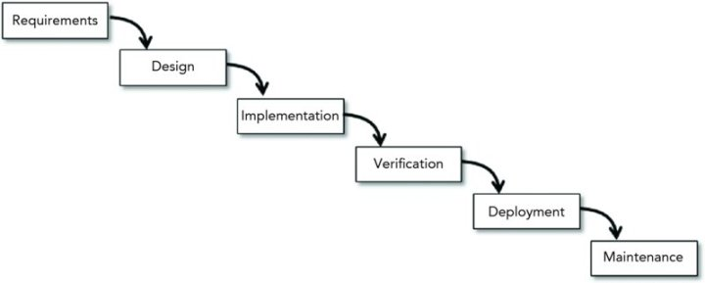

D. DESIGN
The major requirement for American Video Game Company is to have a new CRM software that will keep up with its growth since it has outgrown the existing CRM system. The system should be able to offer a report generating tool, sales tracking ability, and a subsystem to manage client’s information. To accomplish this, a well fit design will be adopted in the development process. This segment will show the storyboard, the UML and the GUI that will be adopted.

D.1 Storyboard
They system will begin by a sales person creating a new contact as shown in the storyboard below.
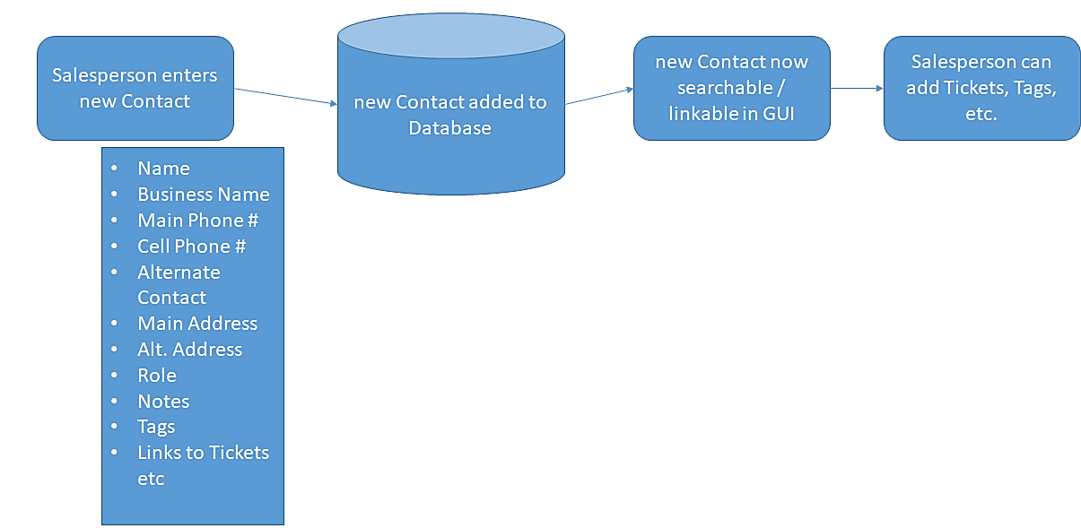

D.2 GUI
The company CRM system is designed to have the following functionalities:
Contact management
All forms are obliged to be able to deduplicate the existing data and able to detect homophonic existence and categorize the typically. This makes data clear and increases efficiency when sales representatives are looking for contacts and as well allow self service among users.
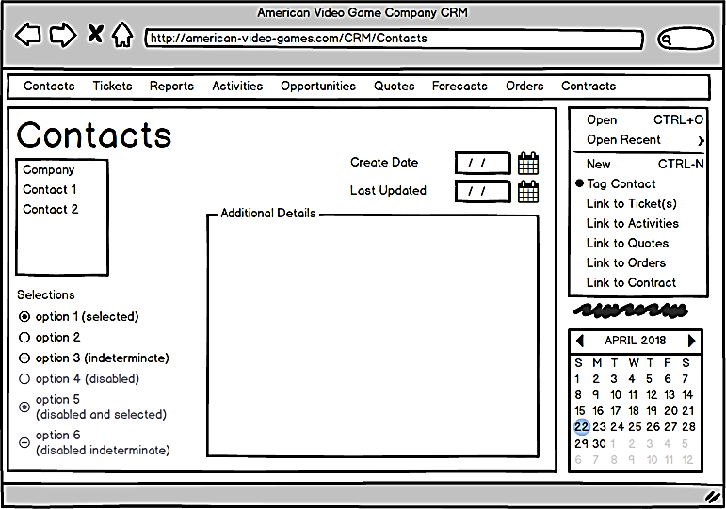
Ticketing
The part of the system concerned with ticketing is expected to and will keep the contact information of the company by giving permission to the force concerned with sale to enter data and track it with communications within the company including all inquiries based on each contact in the firm’s list. The contents of the ticket will be, identity of the caller, the agenda or reason why the individual or organization was calling, the time when the call was made, the day of the call and all the necessary follow-ups which was done on the call and finally any other essential details required about the call. The identity of the tickets is different from one to another, making each of them unique on its own. The replies made on the emails are also captured and a follow up is done based on each contact. The database is designed to bear all the information that is essential if the workflow is to happen.
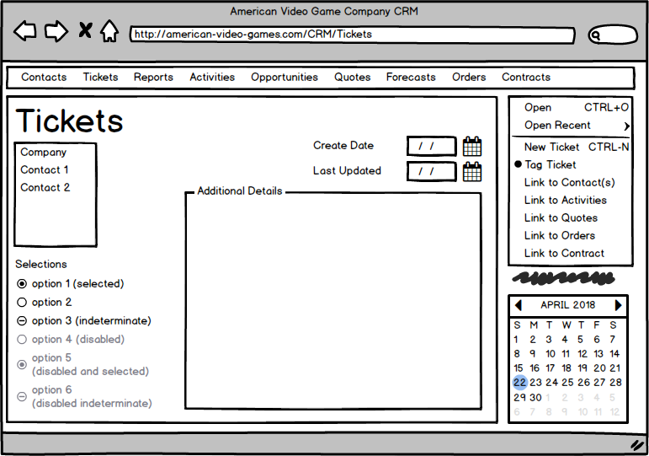
Reporting
The system CRM has an obligation to and it does deliver all the reports whether defined by the user or the predefined ones entailing each piece of data it has in store. The user junction will have a sort of efficiency during use to allow the information to be filtered , edited, queried, formatted and exported. Reporting will also guarantee even the tiniest details of the reports. The reporting in this system will also allow for dashboards to be created, creation of data reports of the past and easy creation of templates used by the senior team to make summary of the progress of the firm’s system and processes. Here, user’s can serve the user interface , do their editing and filtering, and Dave their information in case they want to retrieve it in future.
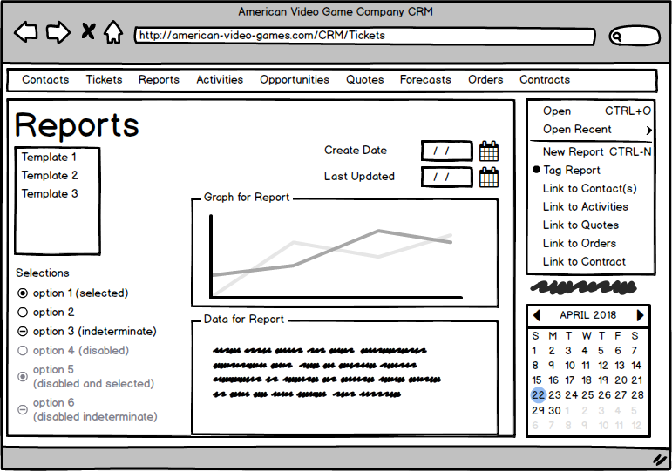
Activity management for visits and meetings
The system swings into action as a storage plan for the information ,data and strategies concerning meetings of the firm’s officials with stakeholders. This system can allow a bit or one-way communication between the system itself and the user. It also supports the ticket function which controls and manages information and data and reporting. The same system will do importing and exporting of data conveniently and precisely and can tag employees to the meeting’s concerns.
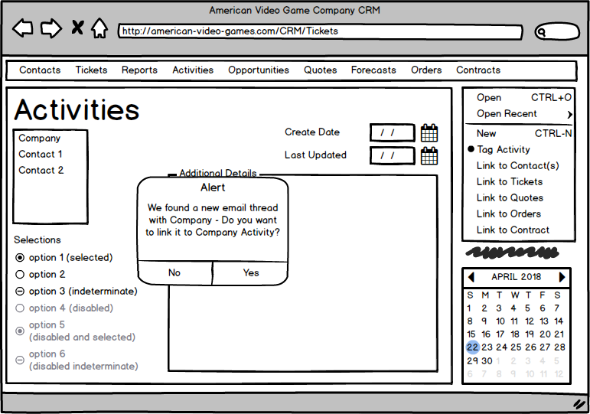
Opportunity management
The customer relationship management (CRM) aquatints the taskforce of sales with the capability to go a follow up with the sale routes and identify their competitors and analyze them as well. After analysis of the competitors, there will be a directed implementation of a kind of a workflow management meant to keep close track of the route and permit the user’s to conduct important analysis related to competency.
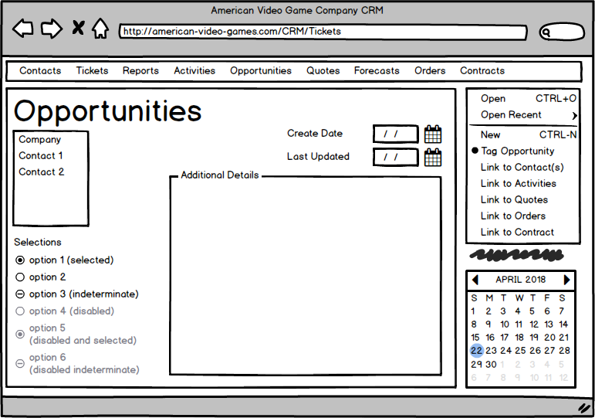

Quoting
The system will be concerned in the generation of quotes , management of the discounting system, control of tax, controlling substitutions and dictating the price catalogue.
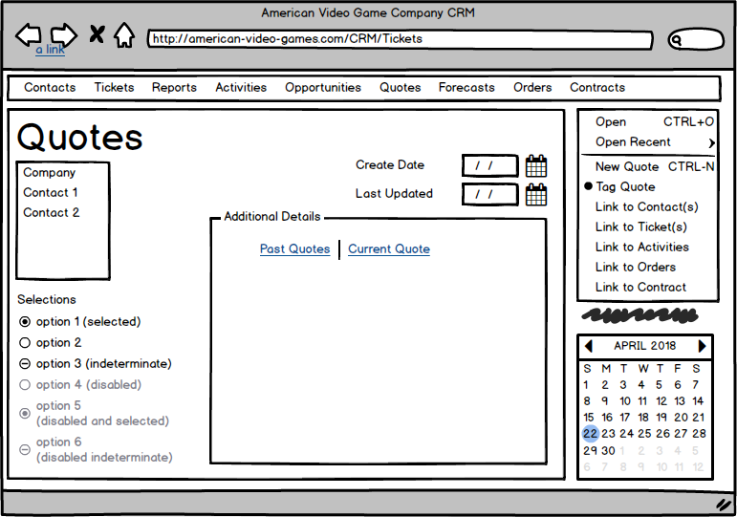
Forecasting
The managers are the group concerned with controlling the sales and the pricing. They look up to forecasts to plan well go the future well-being. The predictions given from the forecast will allow managers to control the domestic and foreign currency, plan for machine adjustments and display impending adjustments pertaining the managerial work.
Contract management
Because all deals are sealed with contracts, the sales force is obliged to manage contracts effectively , failure to which the whole work might get ditched. The CRM system will allow close follow up on the contracts, control approvals and dictate the terms of terminating contracts. The tool must be consistent with it’s predecessor or perform better than it. It should also have a good connection to the user(user friendly) . It should be efficient when it comes to matters of modification ,editing it changing of information. The system is expected to do this without threatening the security of the user’s information or data.

E. TESTING
After the CRM system is complete, a series of tests will be conducted to verify its validity. Below are the tests to be done to the system.

E.1 Testing Details
The workflows to be tested under this section are creating a contact, query of sales and deleting a contact.

E1.1 Create a contact

Requirement to be tested
Create Contact
Preconditions:
A database should have been established with correct parameters in place, and relationships established.
A GUI for creating a new contact mush have been established, where the tester is supposed to key in new user’s details.
Steps:
- Collect information about a fake contact
- Call the create new contact function
- Enter details correctly, following the user requirements
- Confirm entries and proceed to create
Expected results:
After following the above steps, it is expected that the details are captured and stored accurately in the user database, depending on the type of user and the level of interaction.
Pass/Fail:
Pass

E1.2 Query the sales gui from mobile

Requirement
Query of sales
A database should have been established with correct parameters in place, and relationships established.
A GUI for creating a new contact mush have been established, where the tester is supposed to key in new user’s details.
Steps:
- Tester should create a sale
- Add all parameters and save the sale
- The tester should then search for the sale using different parameters
- Note the success or failure of the sale using different parameters

Expected results:
The system is expected to return the sale searched using different parameters.
Pass/Fail:
Pass

E 1.3 delete a contract
Requirement
Deleting a contract

Preconditions:
a database should have been established with correct parameters in place, and relationships established.
A GUI for creating a new contact mush have been established, where the tester is supposed to key in new user’s details.
All the detailed audit logs in the database should be on.
Steps:
- Call the delete contact function from the GUI
- Select the contact created earlier
- Delete the contact
- Examine audit logs from database to confirm that the contact was deleted
Expected results:
The system is expected to return the delete function
The deleted contact should be scraped off from the database
Pass/Fail:
Pass

F. Sources
Baumeister, Hubert. "Customer relationship management for SMEs." The Proceedings. 2002.
Chari, Kaushal, and Manish Agrawal. "Impact of incorrect and new requirements on waterfall software project outcomes." Empirical Software Engineering 23.1 (2018): 165-185.
McCormick, Mike. "Waterfall vs. Agile methodology." MPCS, N/A (2012).
Rosalina, Vidila, and Agung Triayudi. "Electronic Customer Relationship Management (E-CRM) Application as Efforts to Increase Customer Retention of Micro Small and Medium Enterprises (MSMEs) in Banten Indonesia." (2019).

